Super TicTacToe
Software Design Specification
Version 1.0

Revisions
Version | Primary Author(s) | Description of Version | Date Completed
1.0 | Tyler | Initial document | 04/30/2009
1.1 | Robby |  | 05/15/2009
Contents
1 Introduction 1
1.1 System Overview 1
1.2 Supporting Materials 1
1.3 Definitions and Acronyms 1
2 Design Considerations 2
2.1 Assumptions 2
2.2 Constraints 2
2.3 Goals and Guidelines 2
2.4 System Environment 2
2.5 Development Environment 2
3 Architecture 3
3.1 Overview 3
3.2 Strategies 3
3.2.1 Standards 3
3.2.2 Flexibility 3
3.2.3 Scalability 3
3.2.4 Customizability 3
4 High Level Design 4
4.1 Hierarchy Chart Of Components 4
4.2 Sequence Diagrams And Descriptions 4
5 Low Level Design 5
5.1 Component C1 5
5.1.1 Class D1 Of Component C1 5
5.2 Component C2 5
6 User Interface Design 6
6.1 User Interface Design Overview 6
6.2 User Interface Navigation Hierarchy 6
7 Requirements Traceability Matrix 7
8 Appendices 8

Introduction
<Provide an overview of the entire document, including the purpose, the scope and the intended audience of the document. Identify the product using any applicable names and/or version numbers.>

System Overview

<Provide a general description of the software product including its functionality and matters related to the overall system and its design.>

Supporting Materials
<Provide references for any other pertinent documents such as related and/or companion documents, prerequisite documents and documents which provide background and/or context for this document.>

Definitions and Acronyms
<Define any important terms, acronyms, or abbreviations.>
Term | Description
SOA
DFD

Design Considerations

Assumptions
<Describe any assumptions or dependencies regarding the software and its use. These may concern such issues as related software or hardware, operating systems, end-user characteristics, and possible and/or probable changes in functionality.>

Constraints
<Describe any global limitations or constraints that have a significant impact on the design of the system's software. Such constraints may be imposed by any of the following (the list is not exhaustive): hardware or software environment, end-user environment, availability or volatility of resources, standards compliance, interoperability requirements, interface/protocol requirements, data repository and distribution requirements, security requirements (or other such regulations), memory and other capacity limitations, performance requirements, network communications, and other requirements described in the requirements specification.>

Goals and Guidelines
<Describe any goals, guidelines, principles, or priorities which dominate or embody the design of the system's software. Such goals might be: the KISS principle ("Keep it simple stupid!"), emphasis on speed versus memory use, or working, looking, or "feeling" like an existing product. For each such goal or guideline, unless it is implicitly obvious, describe the reason for its desirability.>

Architecture

Overview
< Determine what parts of the application software will be assigned to what hardware. Describe any design decisions and/or strategies that affect the overall organization of the system and its higher-level structures. These strategies should provide insight into the key abstractions and mechanisms used in the system architecture. Describe the reasoning em-ployed for each decision and/or strategy (possibly referring to previously stated design goals and principles) and how any design goals or priorities were balanced or traded-off.>

Strategies

Standards

Technical Environment
<Special hardware, software, and network requirements imposed by business requirements>

System Integration
<The extent to which the system will operate with other systems>

Maintainability
<Expected business changes to which the system should be able to adapt>

Performance
<The time within which the system must perform its functions; the total and peak number of users and volume of data expected; the extent to which the system will be available to the users and the permissible failure rate due to errors>

Software Specification
<Determine software needs, such as OS, development IDE, JDK version, other SDK version, etc. >

Hardware Specification
<
- Clients
  - Input/output devices employed by users
  - PCs, laptops, handheld devices, cell phones
- Servers
  - Larger computers storing software
  - Accessible by many users
- Network
  - Connects clients and servers>

High Level Design
The system has been decomposed into two basic subsystems, the game client, and the artificial intelligence algorithm. This division was necessary to facilitate separation of responsibilities among team members and to provide for parallel development between the two parts.
The two subsystems described above will be incorporated into the final implementation by use of the strategy design pattern. The game client will consist of an AI model interface that will be implemented by the AI subsystem. This will provide for the opportunity to implement a test-driven development lifecycle with the game-client by allowing for a random AI player to be used in testing the interface.

Hierarchy Chart Of Components
<Describe the major responsibilities that the software must undertake and the various roles that the system (or portions of the system) must play. Describe how the system was broken down into its components/subsystems (identifying each top-level component/subsystem and the roles/responsibilities assigned to it). Describe how the higher-level components collaborate with each other in order to achieve the required results. Don't forget to provide some sort of rationale for choosing this particular decomposition of the system (perhaps discussing other proposed decompositions and why they were rejected). >

Game Client
The client application is decomposed into three parts which separate the internal representations of information from the ways that information is presented to or accepted from the user.
The model classes are used for storing game-state information and enforcing the rules of the game. The AI will be defined by a model interface and is responsible for determining moves for the computer player.
Views are implemented using the Java Swing toolkit and provide a user interface for interacting with the game.
Controllers accept input from the user and make changes to the game models, Controllers also interact with the central game server during server matches.
When the state of a model is updated by a controller all related views are notified and subsequently updated.

AI

Sequence Diagrams
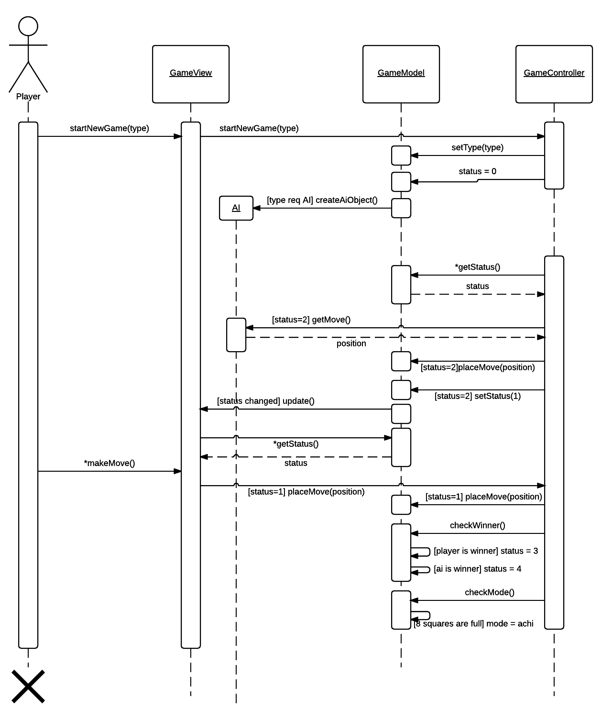

Low Level Design

Client Class Diagram
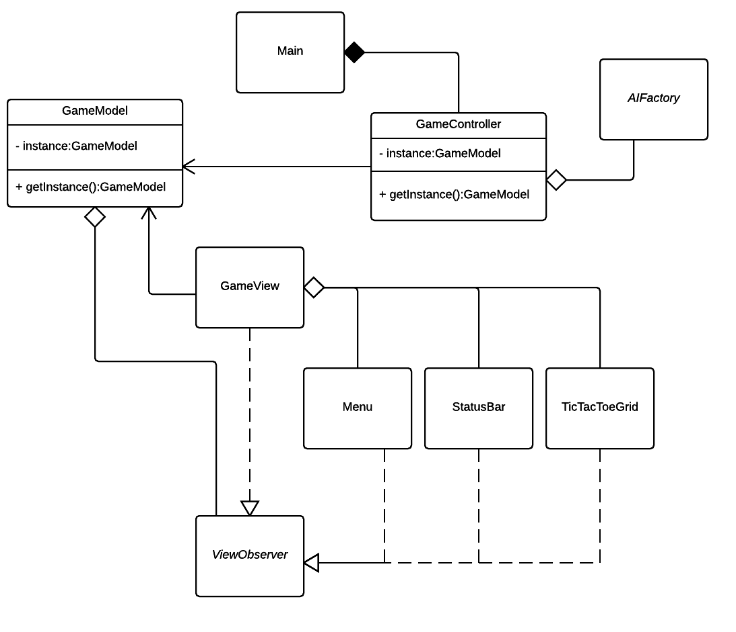

Models
There are two model types, the Game model and AI model. The Game model will maintain a nine element character array to represent the state of the game. Additionally the Game model will track which player's turn it is, provide a list of available moves, and store information necessary for playing a game with the central game server such as game id and player id.

Views
The application will consist of a single window interface defined by the MainWindow View which extends the JFrame class of the Java Swing toolkit. Components of the main window are implemented as separate views. Each view is registered with the Game model and extends a View interface to define the update method.

Controllers
All user interaction and server responses are handled by the GameController class. This class interprets inputs and updates the Game model.

AI
Low level design of AI

User Interface Design

User Interface Design Overview
The application will consist of a single window interface that provides the user with the ability to set up and play a game. There is a three by three grid of buttons for selecting moves, a control panel for configuring game options, and a status bar for providing feedback to the user.
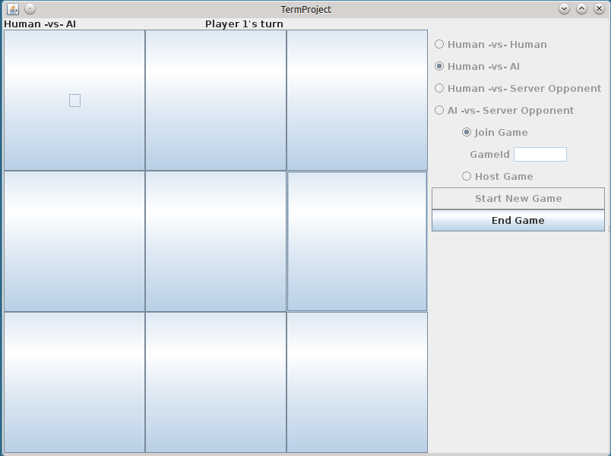

User Interface Navigation Hierarchy
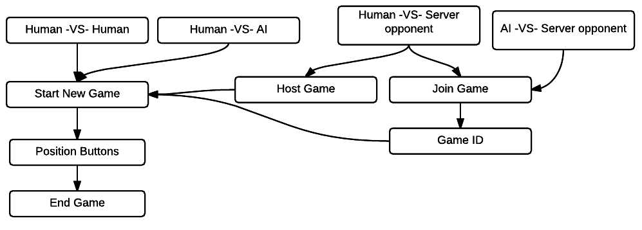

Requirements Traceability Matrix
<Provide reference to the location of the Requirements Traceability Matrix that indicates traceability from the software requirements document to the design elements documented.>
 | f1 | f2
User Interface | Section 5.1.2 Views
r2

Appendices
.

